Task 1: Linux History and Philosophy
- Objective:
To understand the origins of Linux and GNU/Linux principles.
Steps Performed
- Opened terminal
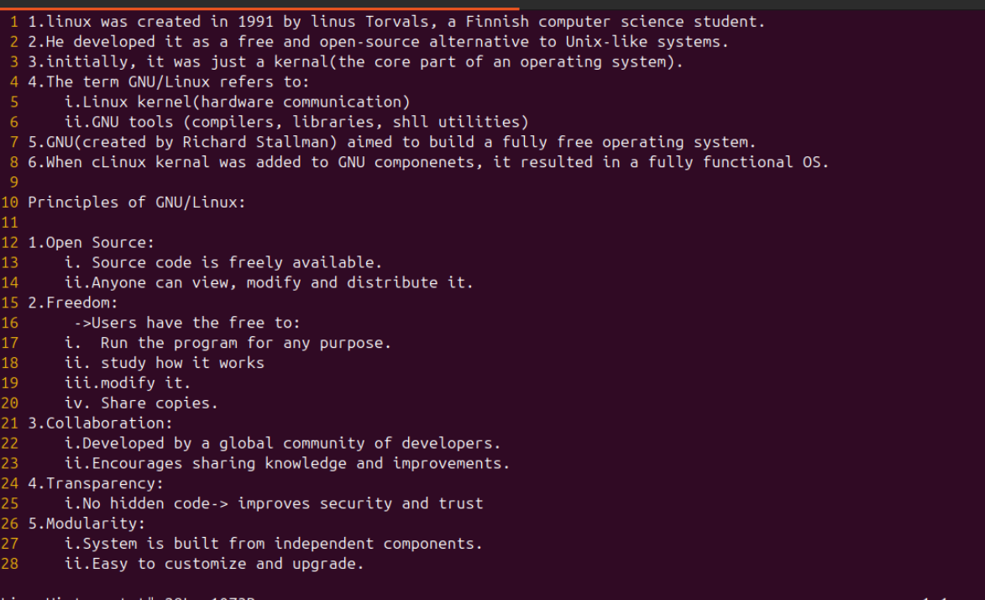
- Created the file by command : nano LinuxHistory.txt

Task 2: File Navigation and Directory Structure
- Steps
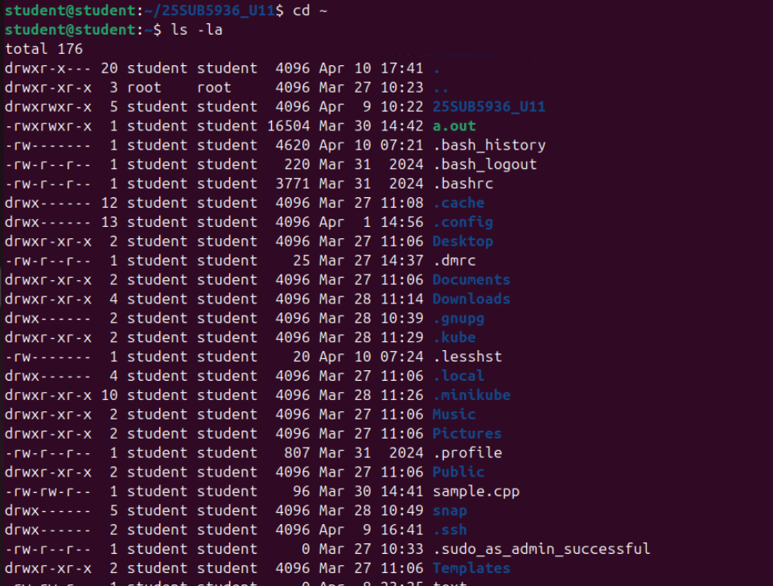
- List files in home directory

- Check current directory path
- Create a new directory
- Move into the directory
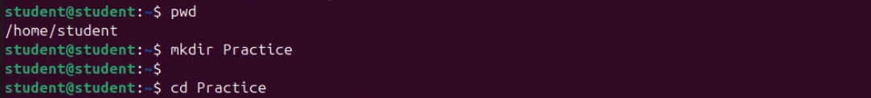
Task 3: File Management Commands:
- Steps
- Copy the file
- Delete duplicate file
- Verify deletion
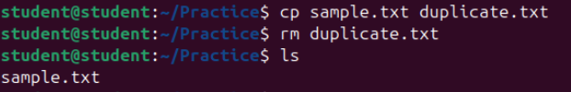
Task 4: Using grep to Search within Files:
Steps:
- Search for word "Linux"
- Save results to new file
- View saved results
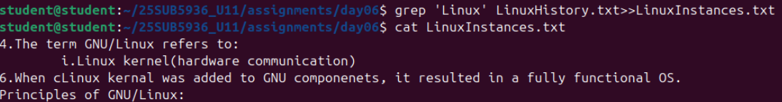
Task 5: Permissions and Ownership:
Steps
- First we need to create a user by command : sudo adduser eeshwar
- Then we need to change ownership.
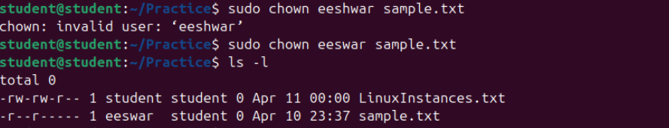

Task 6: Remote ystem Access:
Steps:
- Connect to remote system
- Enter password when prompted
- Copy file to remote system
